**Exercise at class**

By traltb@fe.edu.vn

Koi fish is one of the most popular aquarium fish breeds today. With its graceful beauty and vibrant colors, Japan's national fish is not only popular with aquarium hobbyists but also attracts many breeders for the purpose of decorating their homes, gardens and doing business. To meet the increasing demand of customers who want to own Koi fish originating from Japan, NJS Koi developed software called Koi Order System to manage the provision of services to customers who want to visit and buy Koi directly from famous Japanese farms.

The software enables customers to search for Koi breeds (such as Showa, Sanke, Ogon...) raised by each Koi farm in Japan, with reference selling prices for each breed-size-age. Through the software, the customer has the ability to make Koi purchase reservation to buy fish directly from Japanese farms with desired proposals (breeds, farm, expected departure date, total expenses...). Health information of Koi fish will be reviewed by the system. The system will review the Koi purchase reservation and choose suitable flight routes through the farms and the cost the customer must pay to send a quote to the customer. This quote must be approved by the customer can view it. The customer needs to confirm the quote and pay the cost through the CHPay online payment system before the customer's Koi purchase reservation will be accepted. After the customer has made payment, the system allows the reservation staff to send specific information (airfare, hotel, etc.) to the customer. Before 48 hours of the trip departure date, the customer can cancel the Koi purchase reservation but will have to pay airfare and hotel fee. The manager has the function of assigning the consulting staff to be in charge of the Koi purchase reservation. The consulting staff can only view the Koi purchase reservation assigned to him/her by the manager. At the airport on the departure date of the trip, the consulting staff takes care of the customer on the trip. During a trip to the Koi farm in Japan, the consulting staff updates customer's Koi purchase information after finishing the purchase process with the farm owner into the system. To be able to collect fund, the customer needs to deposit 30% of the value of the fish, this amount is deducted from the customer's wallet in the system. If the amount of money in the wallet is not enough, the customer needs to top up the wallet through the function provided by the system. At the end of the trip, the consulting staff updates the fish delivery date, and the customer can go through the system to view detailed information about the fish delivery date. Only the manager has the ability to assign delivery staff to deliver fish to the customer. After delivering the fish and receiving the customer's remaining payment, the delivery staff will confirm the Koi purchase reservation is completed. The customer will lose his deposit when canceling the Koi purchase reservation or the customer refuses to receive fish delivery due to poor quality of fish from NJS Koi Farm, the fish deposit will be refunded to the customer.

Question 1: Draw a use case diagram based on the answer in question 2 and briefly describe actors and use cases in template provided with this exam paper.

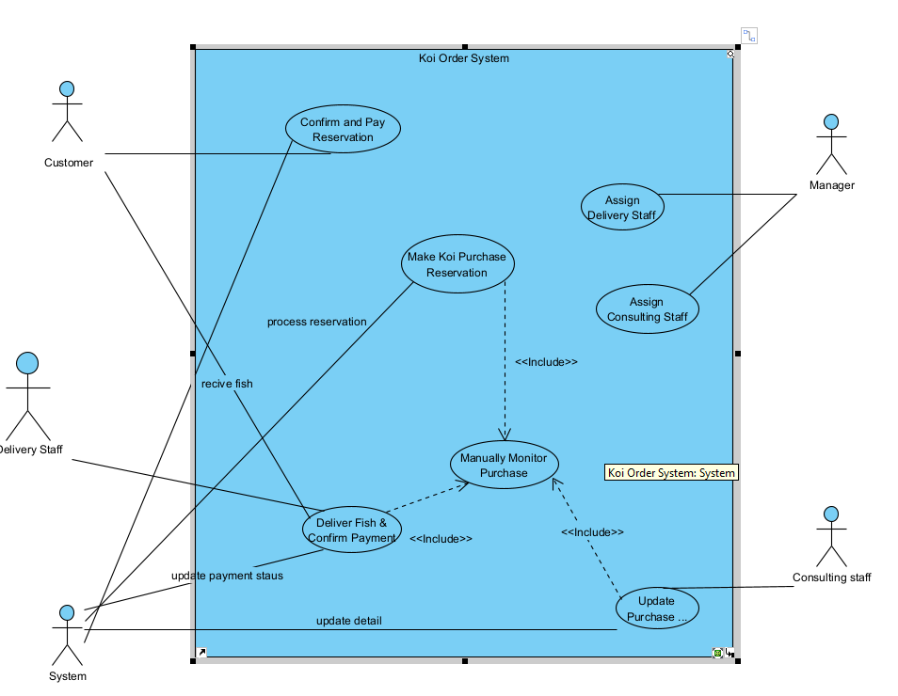

Question 2: Create a Use Case Specification for the "Make Koi Purchase Reservation, based on the following template:

|  |  |  |  |
| --- | --- | --- | --- |
| UC ID and Name: | (0.1 point) the UC – 1 [blank space and the use case name require in the exam paper here.] | | |
| Created By: | trindde180972@fpt.edu.vn | Date Created: | 10/02/2025 |
| Primary Actor: | Customer | Secondary Actors: | System, Consulting Staff, Manager |
| Trigger: | The customer wants to reserve Koi fish for purchase from Japanese farms through the Koi Order System. | | |
| Description: | This use case allows a customer to make a reservation for purchasing Koi fish directly from Japanese farms by selecting breed, farm, expected departure date, and estimated total expenses. | | |
| Preconditions: | 1. The customer must have an account on the system. 2. The customer’s wallet must have sufficient funds for the deposit. 3. The system must have an updated list of available Koi fish breeds and farms | | |
| Post conditions: | 1. The reservation is recorded in the system. 2. The customer receives a quote for the purchase. 3. The customer must confirm the quote and complete the payment for the reservation to be accepted | | |
| Normal Flow: | 1. The customer logs into the system. 2. The customer searches for available Koi fish by breed and farm. 3. The customer selects the desired breed, farm, departure date, and estimated budget. 4. The system reviews Koi health information and generates a quote. 5. The customer receives and reviews the quote. 6. The customer confirms the quote and proceeds with the payment via CHPay. 7. The system updates the reservation status. 8. The manager assigns a consulting staff to the reservation. 9. The consulting staff handles the trip and updates purchase details. 10. The customer deposits 30% of the total fish value. 11. The reservation is completed and updated in the system. | | |
| Alternative Flows: | 1. If the customer's wallet does not have sufficient funds, the system prompts the customer to top up their wallet. 2. If the customer does not confirm the quote within a specific time, the reservation is automatically canceled. 3. If the customer cancels the reservation 48 hours before departure, only the airfare and hotel fees are deducted.…. 4. …. 5. …. | | |
| Exceptions: | 1. f the system encounters an error in retrieving farm data, it notifies the customer to try again later. 2. If payment fails, the system prompts the customer to retry or select another payment method. | | |
| Priority: | High | | |
| Frequency of Use: | Moderate to High, depending on customer demand. | | |
| Business Rules: | 1. Customers must deposit 30% of the fish value before the reservation is confirmed. 2. The reservation can be canceled 48 hours before departure, but airfare and hotel fees apply. 3. The consulting staff can only access reservations assigned by the manager. 4. The manager is responsible for assigning delivery staff for fish delivery. | | |
| Other Information: | The system must ensure secure payment processing via CHPay. | | |
| Assumptions: | 1. Customers understand the refund policies and reservation procedures. 2. The system is always up-to-date with real-time Koi fish availability. | | |

Question 3: Write down 4 business rules used in the use cases described in question 2 in template provided with this exam paper.

1. Customers must deposit 30% of the fish value before the reservation is confirmed.
2. The reservation can be canceled 48 hours before departure, but airfare and hotel fees apply.
3. The consulting staff can only access reservations assigned by the manager.
4. The manager is responsible for assigning delivery staff for fish delivery.